**Bayes Theorem**

**Aim: Implement Bayes Theorem using Python.**

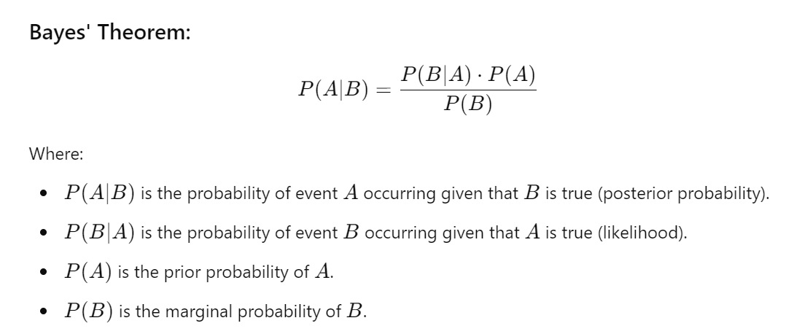

Procedure:

To implement **Bayes' Theorem** on the **Iris dataset** (iris.csv), we first need to load the dataset and define events A and B. For the sake of this example, we can define:

* A: The class of the iris flower (e.g., setosa, versicolor, virginica).
* B: Some observed feature value (e.g., petal length, sepal width).

Let's assume we want to calculate the probability that a flower belongs to the class setosa given that its **sepal length** is greater than some threshold (say 5.0 cm).

**Steps:**

1. Load the iris.csv dataset.
2. Define the event (flower class) and feature (sepal length)
3. Compute prior P(A), likelihood P(B∣A), and marginal probability P(B).
4. Apply Bayes' Theorem.

**Events:**

A: Flower is Setosa

B: sepal length being greater than 5.0 cm

**Steps Breakdown:**

1. **Prior Probability P(A)**: The probability of the flower being setosa (without any conditions).
2. **Likelihood P(B∣A)**: The probability of the sepal length being greater than 5.0 cm, given the flower is setosa.
3. **Marginal Probability P(B)**: The probability of the sepal length being greater than 5.0 cm, across the whole dataset.
4. **Posterior Probability P(A∣B)**: The probability that a flower is setosa, given that its sepal length is greater than 5.0 cm.

import pandas as pd

def bayes_theorem(prior_A, likelihood_B_given_A, marginal_B):

"""

Calculate the posterior probability using Bayes' Theorem.

:param prior_A: P(A) - Prior probability of A

:param likelihood_B_given_A: P(B|A) - Likelihood of B given A

:param marginal_B: P(B) - Marginal probability of B

:return: P(A|B) - Posterior probability of A given B

"""

return (likelihood_B_given_A * prior_A) / marginal_B

# Load the Iris dataset

def load_iris_dataset(file_path):

return pd.read_csv(file_path)

# Calculate prior probability P(A)

def calculate_prior(data, class_col, class_value):

return len(data[data[class_col] == class_value]) / len(data)

# Calculate likelihood P(B|A)

def calculate_likelihood(data, class_col, class_value, feature_col, feature_condition):

subset = data[data[class_col] == class_value]

return len(subset[subset[feature_col] > feature_condition]) / len(subset)

# Calculate marginal probability P(B)

def calculate_marginal(data, feature_col, feature_condition):

return len(data[data[feature_col] > feature_condition]) / len(data)

# Apply Bayes' Theorem on the Iris dataset

def apply_bayes_to_iris(file_path, class_col, class_value, feature_col, feature_condition):

# Load dataset

data = load_iris_dataset(file_path)

# Calculate prior P(A)

prior_A = calculate_prior(data, class_col, class_value)

# Calculate likelihood P(B|A)

likelihood_B_given_A = calculate_likelihood(data, class_col, class_value, feature_col, feature_condition)

# Calculate marginal probability P(B)

marginal_B = calculate_marginal(data, feature_col, feature_condition)

# Apply Bayes' Theorem

posterior_A_given_B = bayes_theorem(prior_A, likelihood_B_given_A, marginal_B)

return posterior_A_given_B

# Example usage:

# Assume we want to calculate the probability P(Class='setosa' | SepalLength > 5.0)

file_path = 'iris.csv' # Path to the iris dataset file

class_col = 'species' # The column representing the class (A)

class_value = 'setosa' # The class value we're interested in (A)

feature_col = 'sepal_length' # The feature we're using (B)

feature_condition = 5.0 # The condition on the feature (B > 5.0)

# Calculate posterior probability P(setosa|sepal_length > 5.0)

posterior_probability = apply_bayes_to_iris(file_path, class_col, class_value, feature_col, feature_condition)

print(f"P({class_value} | {feature_col} > {feature_condition}) = {posterior_probability:.4f}")